DEV CADWorker Set-up
Schindler CRD Applications

Exported on 2025-08-19 05:07:44

Table of Contents

No table of contents entries found.

CAD-Worker Set-up for Creo 10.0.4.0 and Creo View Adaptor 11.1
- Installation of Creo View adaptor.

- Extract the zip and run setup.exe as admin.

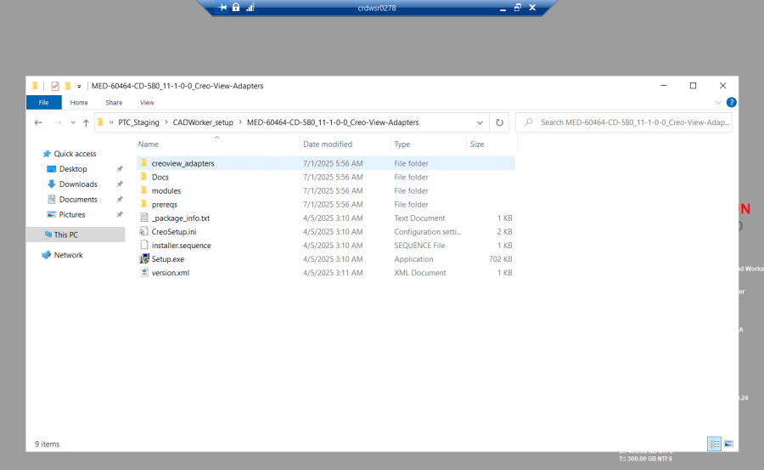

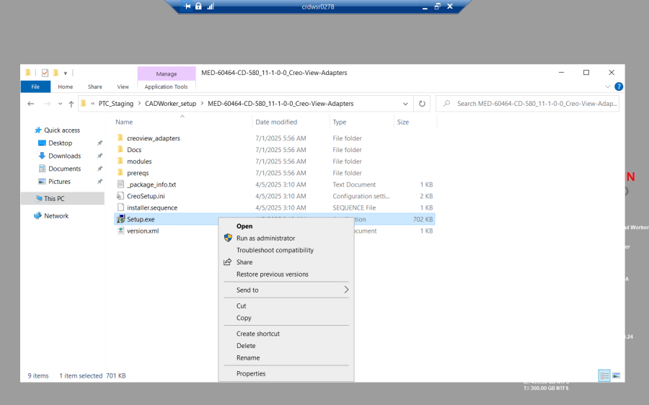

2. Click next.

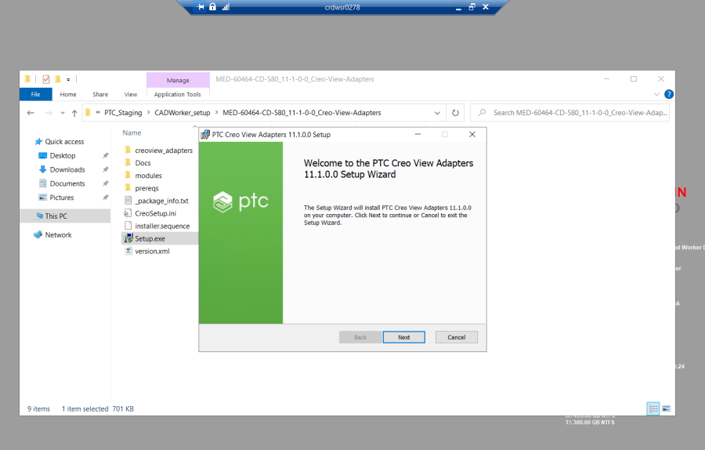
3. Accept and click next

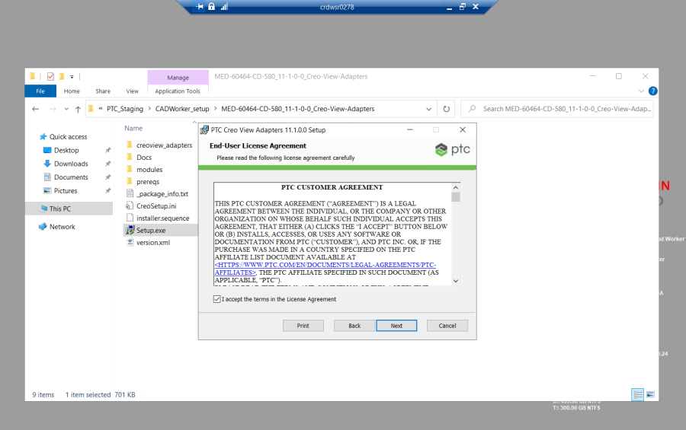
4. Make sure to select below features to install if not selected.

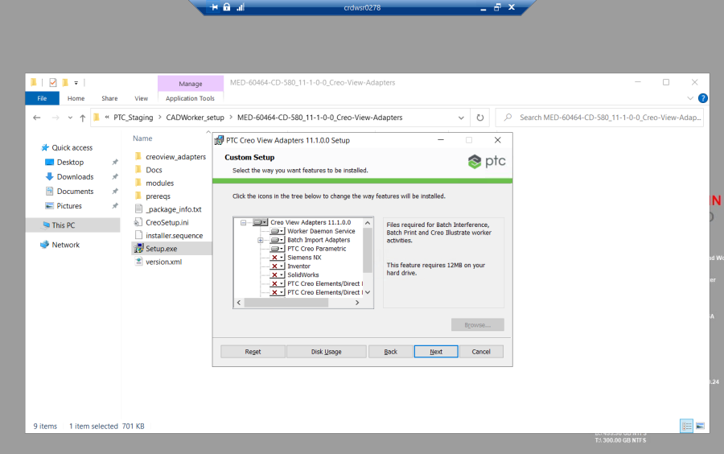

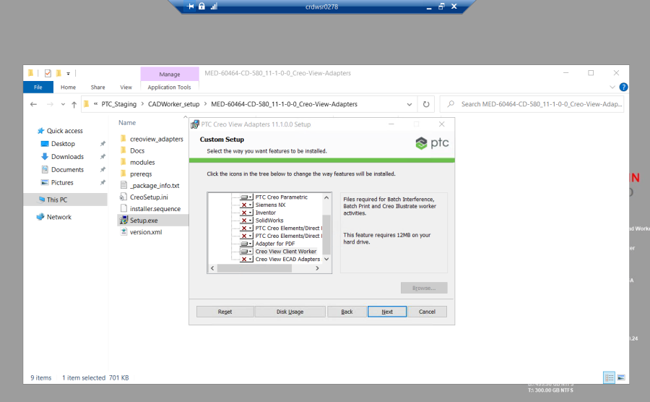
5. Update the path for installation as shown.

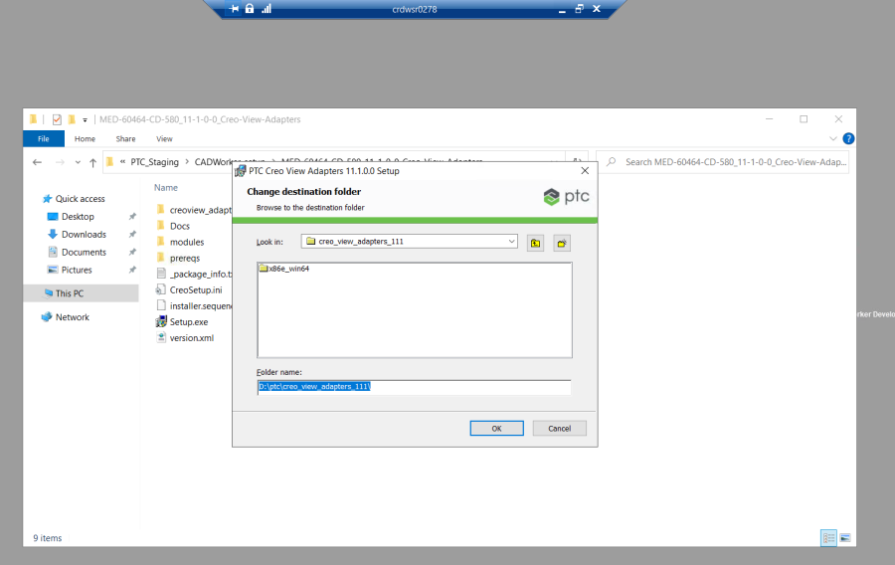
l 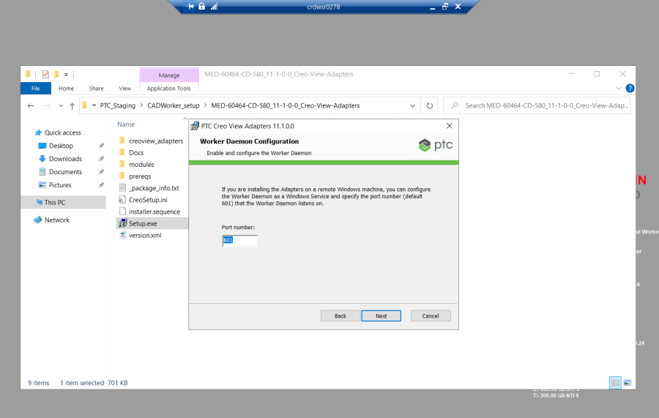

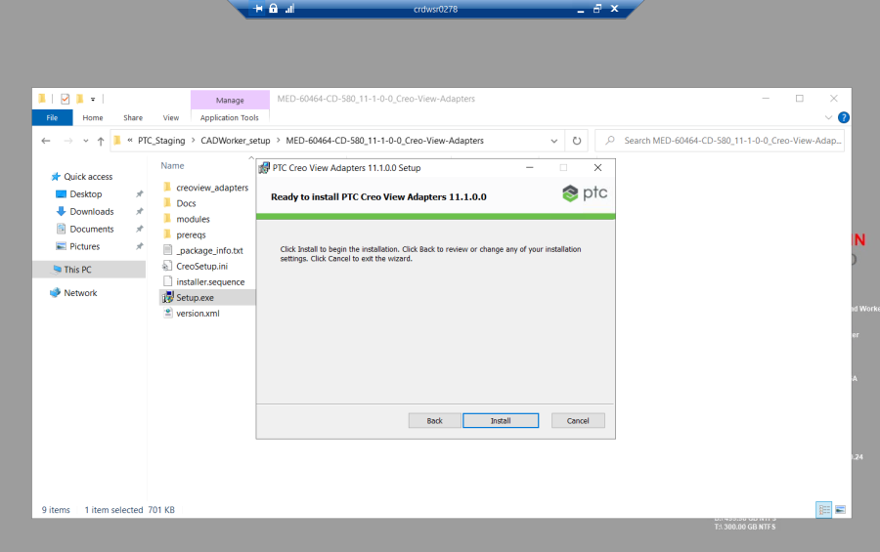

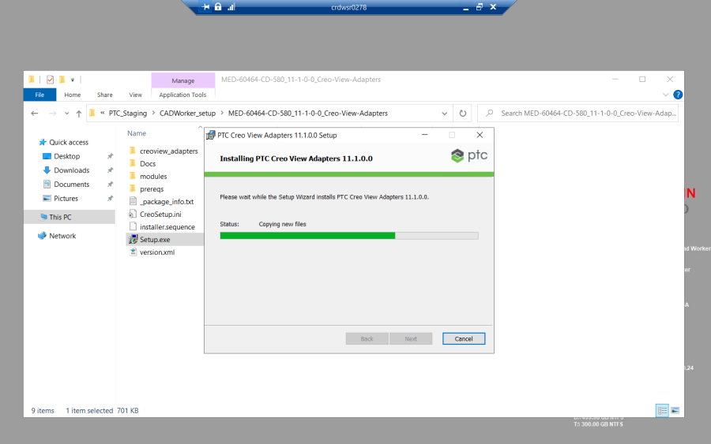

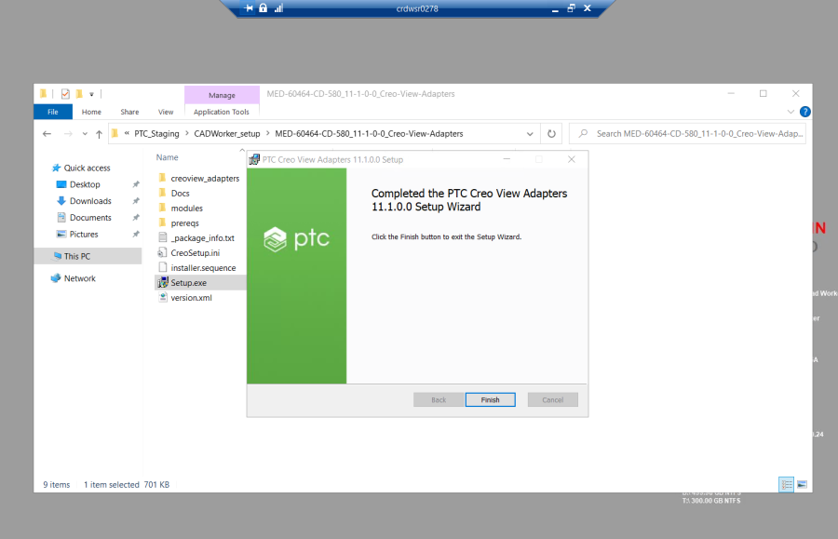

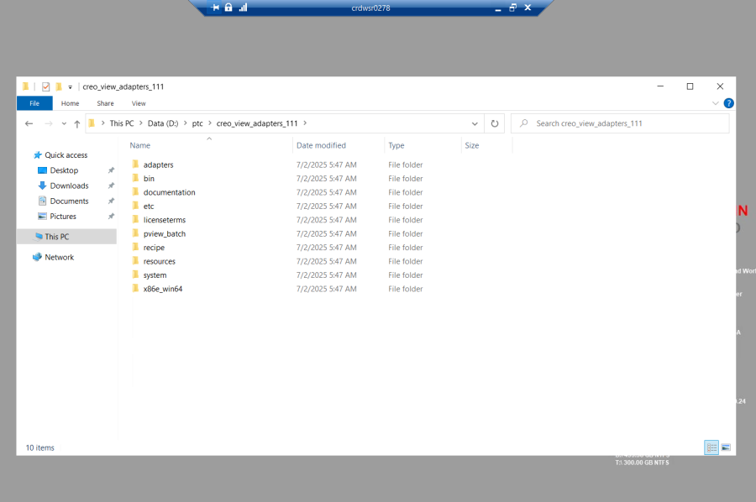

- Installation of Creo 10
- Run the set-up as admin.

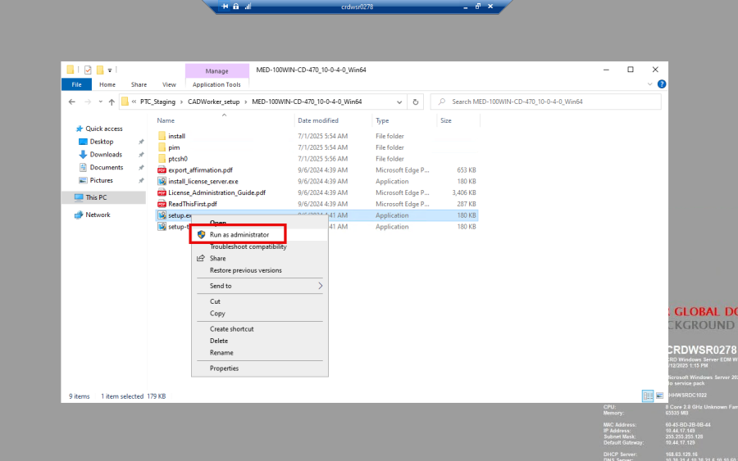

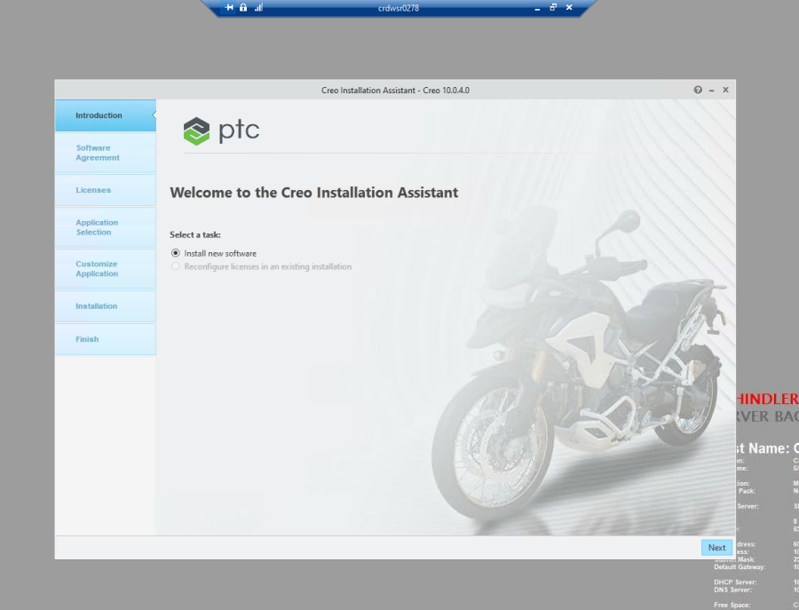

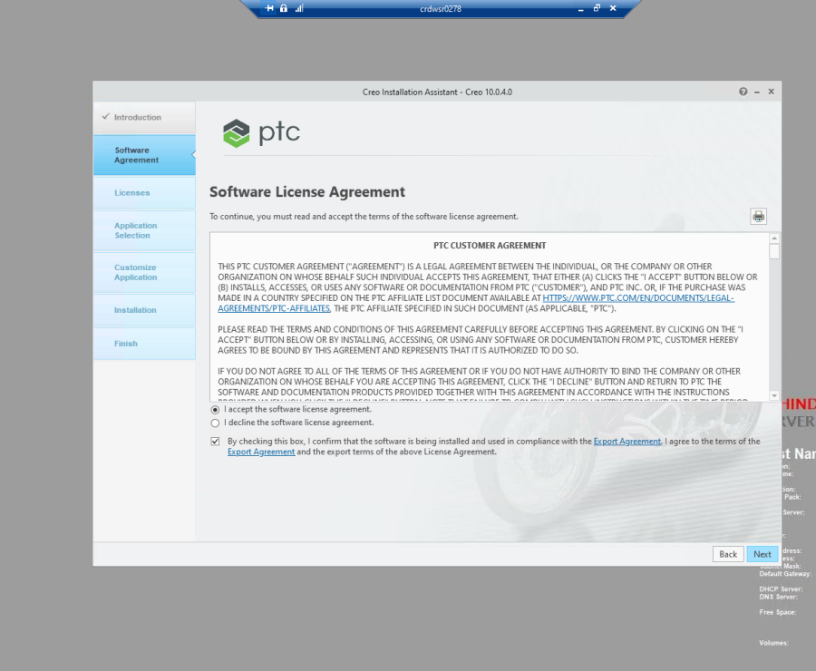

Provide the license server path.

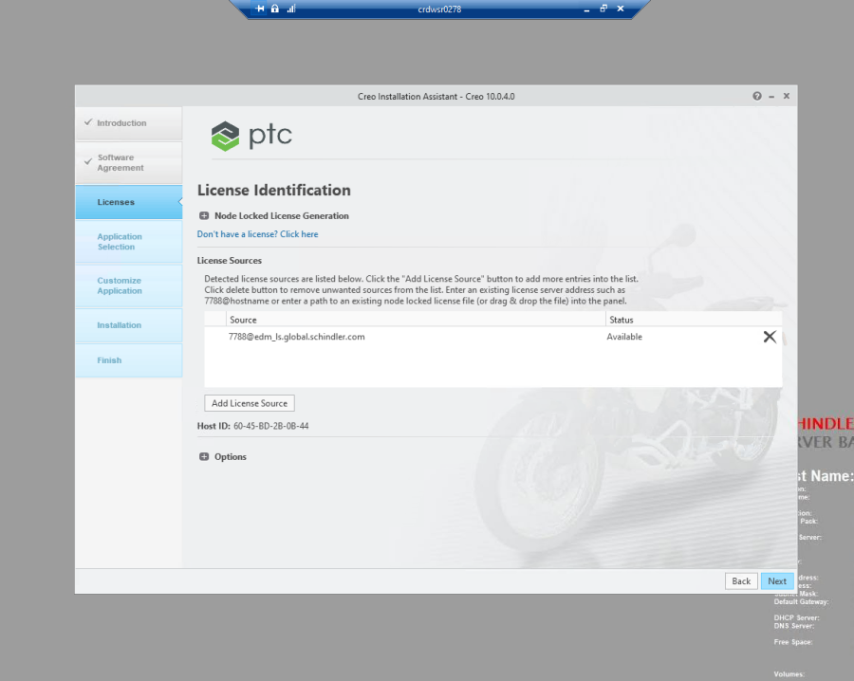

Select the application to install as shown below and uncheck Enable diagnostic data collection for these application.

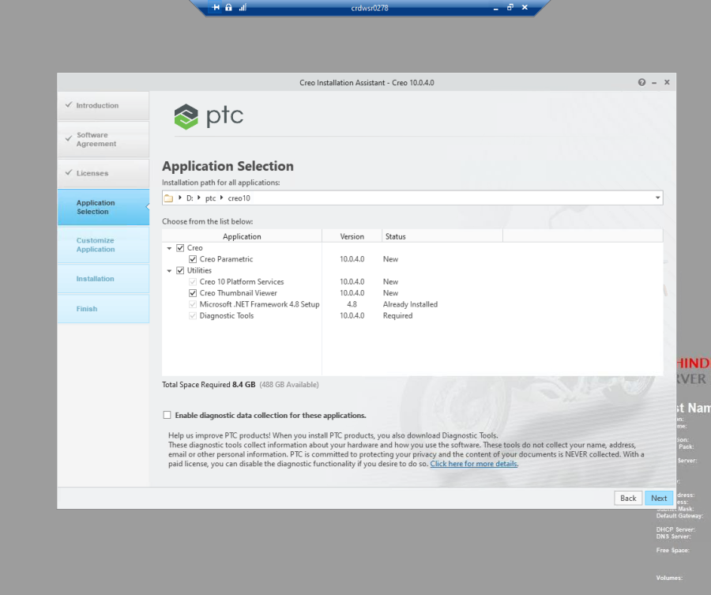

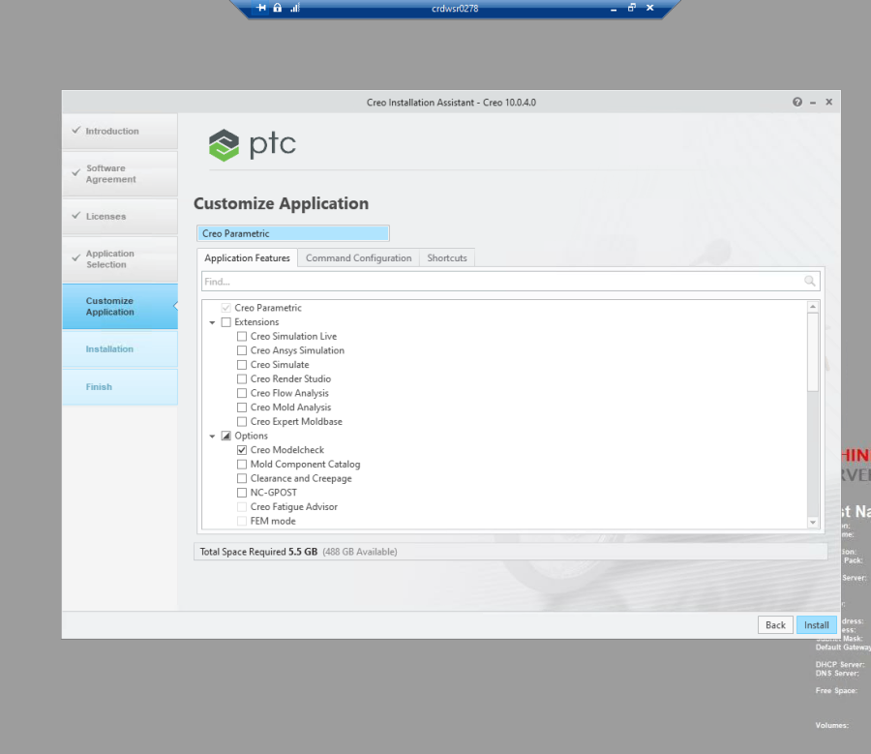

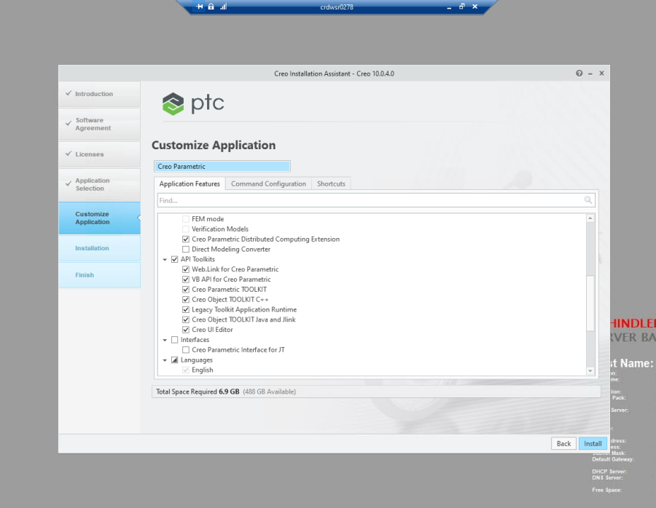

Make sure under language Chinease simplified is selected.

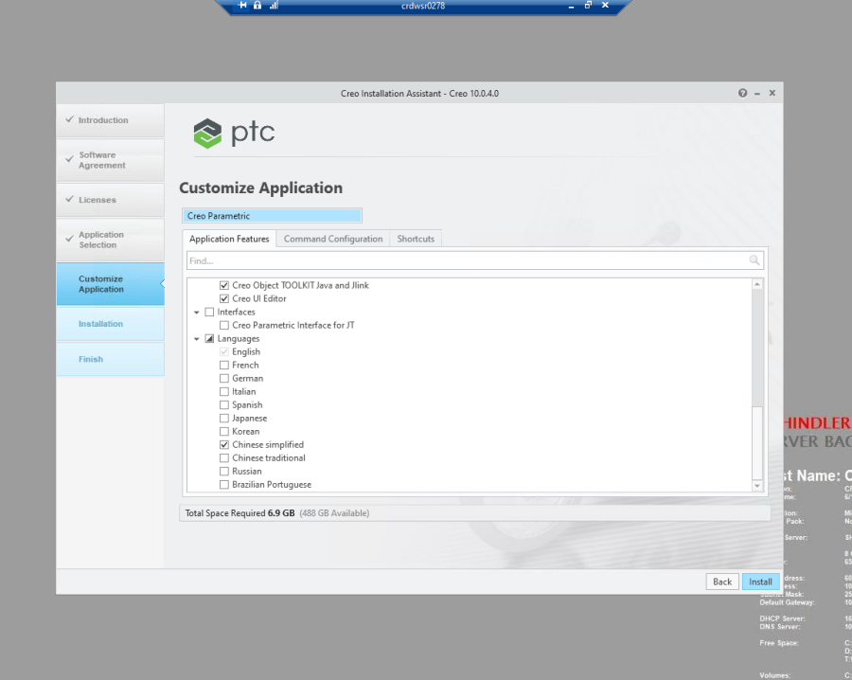

Remove all license and only keep below two license.

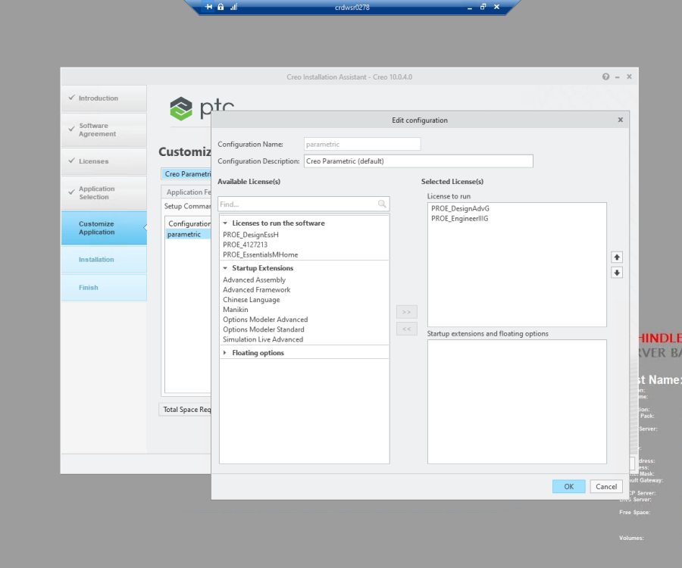

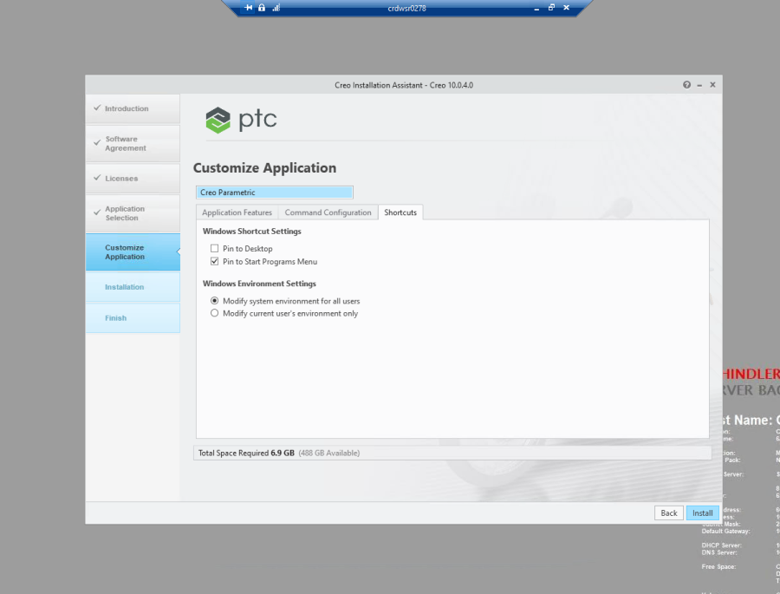

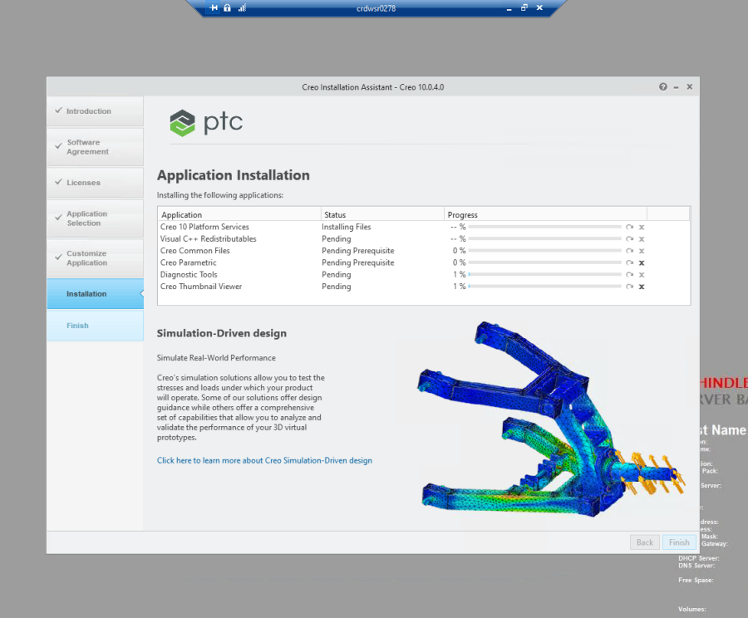

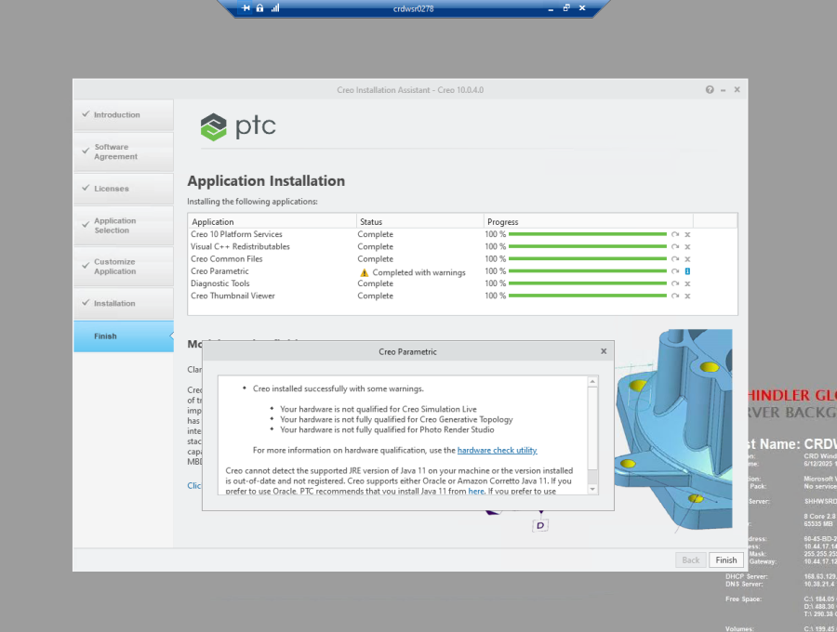

3. Copy CADWorker and checkregen folder from PROD to New CADWorker server.
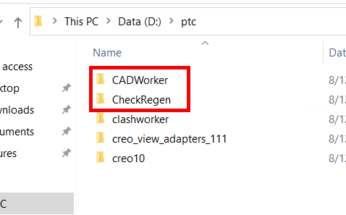

4. Go to each worker folder and edit proeworker1.bat and update the server path and save. ( See below snap :- depending upon the server you connected you need to update server name )
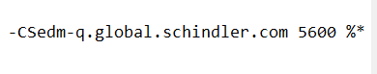
5. Either you make the entry in agent.ini OR you can add one by one worker from worker administration page from site utilities.

6. Reload the worker and start all worker.

